**МІНІСТЕРСТВО ОСВІТИ І НАУКИ УКРАЇНИ**

**Чорноморський національний університет імені Петра Могили**

**Факультет комп’ютерних наук**

**Кафедра «Інтелектуальних інформаційних систем»**



з індивідуальної роботи **МІР М.2.3.1**

**ТФКЗ теорія функцій комплексної змінної**

**Виконав:**

**Cтудент 201 групи**

Грабовський Є.О..

(підпис)

_____________

(дата)

**Викладач**

Кутковецький В.Я.

(підпис)

_____________

(дата)

Миколаїв - 2020

**Laboratory work №2**

**Task:** To find the optimal solution for the release of two resources (pepper and money) using the “Mathcad” program and making a graphic-analytical calculation.

**Step 1.** We have a special table 1.1 with information about the products. This information will be useful in drawing up equations.

|  |  |  |  |  |
| --- | --- | --- | --- | --- |
| **Resource** | **Stock** | **Cost rate** | | |
| **P. 1** | | **P. 2** |
| Pepper | 100N | 7 | 0.2 | |
| Money | 120N | 0.4 | 5 | |
| Δt | | 5 | 0.2 | |
| Profit for 1 product | | 10 | 3 | |
| Intensification | | 2 | 15 | |

*Tab. 1.1.*

**N = 8**

**Step 2.** Formulas of **F1 and F2**.

**x1≥0**

**x2≥0**

**F1(x1; x2) =10*x1+3*x2** *(1);*

**F2(x1; x2) =2*x1+15*x2** *(2);*

**7*x1+0.2*x2 ≤ 800** *(3)*;

**0.4*x1+5*x2 ≤ 960** *(4)*.

**Step 3.** Graphic-analytical calculation.

1. Maximum x1 for axis x1 (x2=0).
   1. 7*x1+0 ≤ 800;

7*x1 ≤ 800;

7*x1= 800;

x1= 114.

* 1. 0.4*x1+0 ≤ 960;

0.4*x1 ≤ 960;

0.4*x1 = 960;

x1=**2400** **(so we use this one on axis x1).**

1. Maximum x2 for axis x2 (x1=0).
   1. 0+0.2*x2 ≤**800**;

0.2*x2 ≤**800**;

0.2*x2 =**800**;

x2=**4000 (so we use this one on axis x2).**

* 1. 0+5*x2 ≤**960**;

5*x2 ≤**960**;

5*x2 =**960**;

x2=192.

1. Replacing inequalities with equations with the aim to show them on the graphic.

For line *(2)*:

|  |  |  |
| --- | --- | --- |
| X1 | 0 | 114 |
| X2 | 2400 | 0 |

For line *(3)*:

|  |  |  |
| --- | --- | --- |
| X1 | 0 | 4000 |
| X2 | 192 | 0 |

The result is on *pic.4.3*.

1. **Drawing up F1.**

Let F1=3000; As a result, we have x1=300 and x2=1000. The graphic of F1 is on the *pic. 4.3*.

**Drawing up the F2** on the polygon.

Let F2=1500; As a result, we have x1=750 and x2=100. The graphic of F2 is on the *pic. 4.3.*

*Pic.4.3*.

F1:

x1 ≈109

x2 ≈183

**F1 =1639**(**the maximum**).

**RESULT:** Maximum **profit** is **x1=109, x2=183**.

F2:

x1 ≈ 109

x2 ≈ 183

**F2= 2963** (**the maximum**).

**RESULT:**

**x1=109**

**x2=183.**

**Step 4.** Obtaining results using MathCad program.

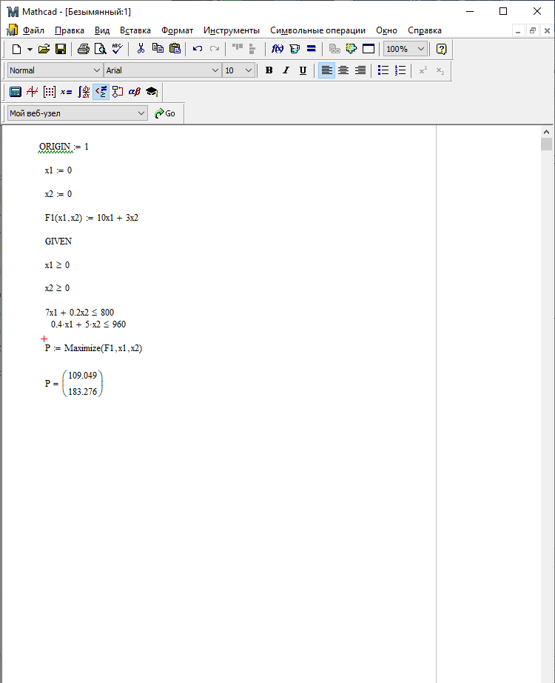

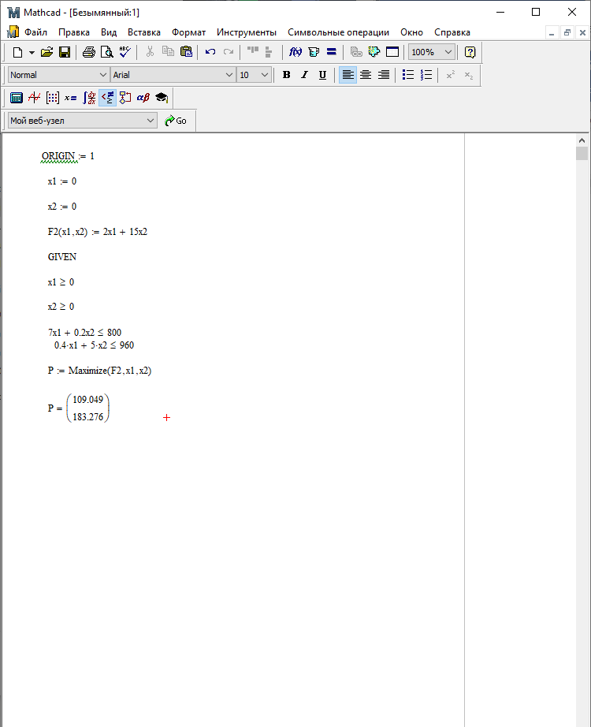

**RESULT:** Maximum intensification of profit is **x1=109, x2=183.**

Thus, we can be convinced that the program result is the same one as we got doing the graphic-analytical calculation.